Look, LeBron is amazing. He smashed my expectations for him in these playoffs. I prematurely crowned Stephen Curry the best player in basketball and LeBron reminded me who the NBA’s true alpha dog is. He is without a doubt a top-10 all-time player, and there’s a very strong argument to be made that he’s already a top-5 guy.

But can we keep our heads on straight please? He brought ONE championship to his hometown. He is not Michael Jordan. Will he be one day? Unlikely, but it’s not impossible. Right now though, MJ is still the gold standard. He’s not the king of basketball, he’s the God of basketball. Is it unfair to compare LeBron to Jordan? Yeah, kind of. LeBron should be appreciated for his own accomplishments. But when you’re this good you can’t avoid the comparisons.

*The Washington Post*(same guys who crowned Manning the GOAT after doing nothing in the Broncos Super Bowl win) [claimed that LeBron was officially more valuable than MJ ever was](https://www.washingtonpost.com/news/fancy-stats/wp/2016/06/20/lebron-james-passes-michael-jordan-as-most-valuable-player-in-nba-history/). The writer cited James’ slightly better statistics in elimination games compared to MJ, ignoring the fact that Jordan consistently kept the Bulls out of those kind of situations. Other things *The Washington Post*conveniently forgot include the fact that MJ was a LOCKDOWN defender and that he has more 45-point playoff games than the next three guys combined. Jordan also would’ve killed someone before he ever let his team fall behind 3 games to 1.

*Britannica*posted [the most ludicrously incorrect list of the NBA’s 10 greatest players](http://www.britannica.com/list/the-10-greatest-basketball-players-of-all-time).

And since when is beating a 73-9 team a better accomplishment than winning 72 games and a championship?? Can a player for a 57-win team really be considered more valuable than a player of the same caliber playing for a 72-win team?

(I also want to note that triple-doubles are deceptive. LeBron was miles short of impressive in game 7. He missed two-thirds of his shots and had 5 turnovers. He finished the game with a plus/minus rating of +4. To put that in perspective, Kevin Love finished game 7 with a plus/minus of +19, and J.R. Smith finished with +10. It’s also not hard to get 11 assists when you throw a million passes.)

There’s two sides to basketball. Offense and defense. Let’s look at defense first. Starting with Michael.

**MJ:**

* 9x NBA All-Defensive 1st Team (all in a row excluding his two year hiatus)
* Averaged 2.3 SPG for his career
* Best steals season – 3.2 SPG
* Best blocks season – 1.6 BPG

**LBJ**

* 5x NBA All-Defensive 1st Team
* Career average of 1.7 SPG
* Best steals season – 2.2
* Best blocks season – 1.1

MJ is considered to be arguably the best defensive player of his era and best perimeter defender ever. I’ve seen LeBron get blown by more times than I care to count.

The offensive end is where the differences become much clearer.

**MJ**

* Thirty 50-point games
* Five 60-point games
* 173 40-point games
* 562 30-point games
* 10 Scoring Titles
* He averaged 31.5 PPG, 6.3 RPG and 5.4 APG with the Chicago Bulls
* Won MVP, Finals MVP, scoring title and NBA championship at the age of 35
* In 1986-87 Jordan posted ***37***40-point games O.o
* 23 game-winning shots in 15 seasons.

**LeBron**

* Nine 50-point games
* One 60-point game
* 49 40-point games
* 304 30-point games
* One Scoring Title
* 17 game-winning shots in 13 seasons

(Kobe has 36 game-winners. Damn.)

I will admit, I understood *The Washington Post’s* article when I first saw it. I disagreed vehemently, but I got it. LeBron added a defining entry to his legacy and he almost singlehandedly destroyed Golden State in games 4 & 5. (Don’t forget how good Kyrie was though. He was the second-best player on either team in the Finals.) But I could not understand the article after I read this excerpt from it:

“[LeBron is} also arguably the most clutch player in NBA history. And yes, that list includes Michael Jordan.”

We are on earth right? I just want to make sure because I didn’t believe this line of thinking was even possible. As if Bird, Magic, Kobe, Kareem, Russell, West, Reggie Miller, John Havlicek, Paul Pierce and Dirk Nowitzki never existed. That isn’t just disrespectful to Jordan, it’s disrespectful to any great clutch performer who never had a moment even remotely resembling LeBron’s meltdown in the 2011 Finals and the 2010 Eastern Conference Semifinals.

LeBron has become more clutch over the years. He’s not the choke artist he once was. But he was indeed a choke artist. For his first eight seasons, he was not mentally capable of winning a championship. That can’t be forgotten.

(Because of the different era and difference in available statistics, it was difficult to find perfectly comparable stats between LBJ and MJ.)

LeBron is a ghastly 5-47 when shooting game-winning/game-tying shots in the final five seconds of the 4th quarter and OT. Yikes. In the playoffs Michael shot 9-18 on game-tying/game-winning shots in the the final 24 seconds of the 4th quarter and OT. He is the only player to take at least 13 of those types of shots and make at least 43% of them.

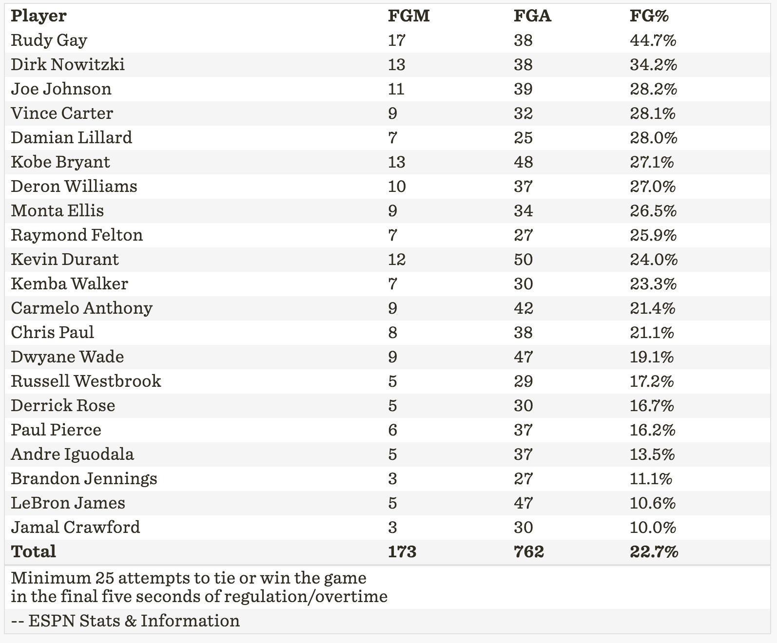

(Posted March 1, 2016)

My final—and maybe most important—reason why MJ is greater than LBJ is reverence. Do some research and you’ll be in awe of the respect Jordan’s contemporaries had for him. Reggie Miller trash-talked everyone on planet Earth. But not Jordan. Miller claims he never tried to trash-talk MJ. That’s a far cry from Draymond Green calling LeBron a bitch. The number of stories about guys who opened their mouths to MJ and got annihilated is almost infinite. Jordan literally instilled fear in his opponents.

Everyone in the league respects LeBron’s talent. But, they don’t all respect him. That counts for a lot. Players don’t fear him like they did His Airness. Remember all the negative comments LeBron got from NBA legends after he fled to Miami? NBA Legends were offended. Guys who stuck with one team for years couldn’t believe that someone so talented was afraid to be ‘The Man.’ And why didn’t he want to beat Dwyane Wade, rather than joining him? You know, like every other superstar ever.

Still, the man can’t be denied. He led both Finals teams in points, assists, rebounds, steals and blocks.

(He won blocks cuz both teams played small-ball. 2.2 BPG is no joke though. And even if he didn’t have the most blocks, dominating 4 out of 5 categories is damn impressive.)

Listen, if you want to tell me LeBron James is a top five player, fine. I can respect that. Hell, I’ll even listen to you if you think he’s the second best player ever (It’s Bill Russell). But best player ever? Most clutch ever? Better than MJ?? Get out of here.

Last argument:

Jordan in the Finals: 6-0

LeBron in the Finals: 3-4

Nuff said.

